# Step 1 Replication

In this Step 1 that is Replication Stage, I run the program in accordance with the User Acceptance Use Cases to show the buggy behavior in the program.

As reported the code has 2 bugs –

1. All the Service Charges are shown as 0.0 while checking out
2. The room can be charged and checked out even after the checkout processes is completed

Initially I started running the program with the Book a Room case. The screenshots are provided below. This booking case had no bug as it gave the confirmation number properly.

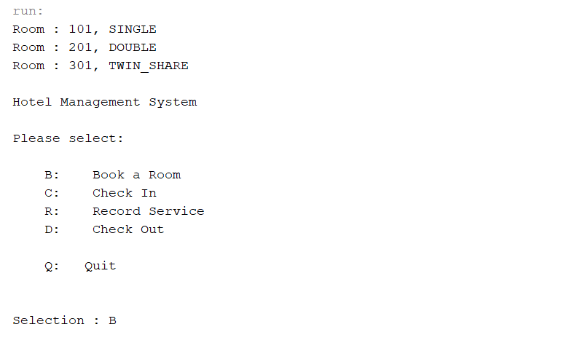

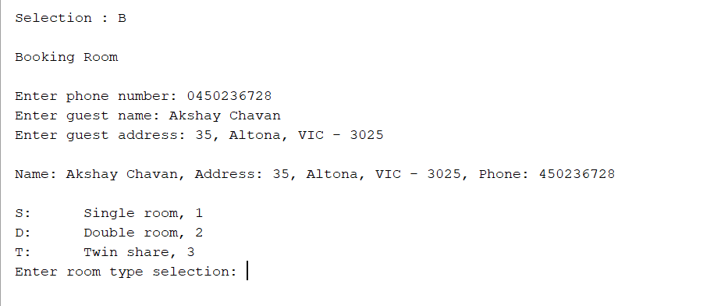

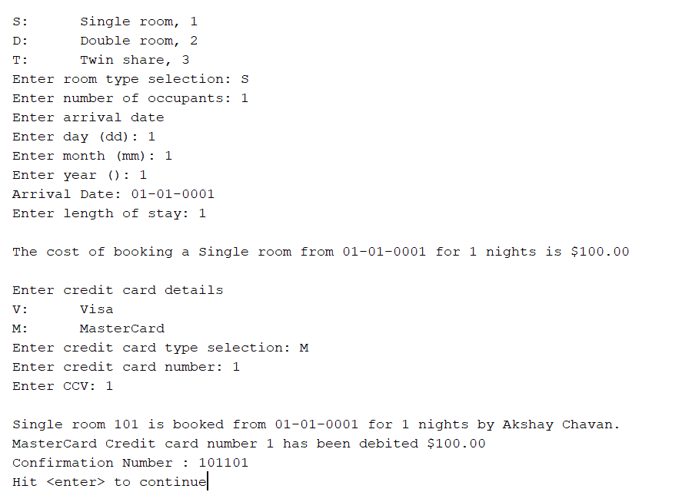

The next case to study was the check in case. This case ran properly as it checked in the guest.

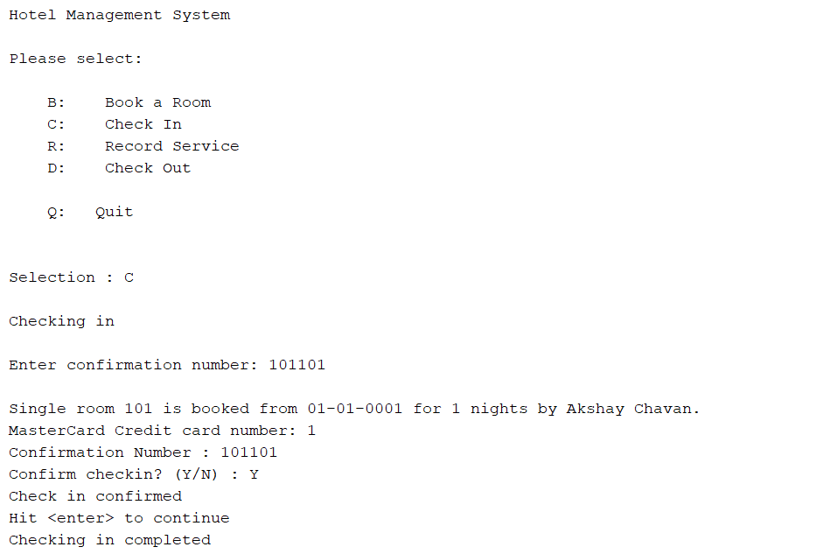

The third one was the record services. This case also passed without any sin of bug. It can successfully add the service charges and also show the total charges in the end.

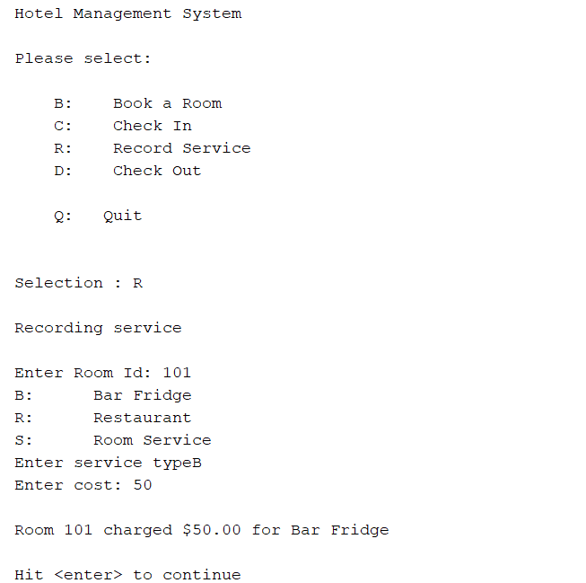

Finally, the checkout process was tested. It showed the signs of the bugs. As reported it displayed the service charges as 0.0 instead of 50 (example that is used). This is the first bug. The below screenshot shows it –

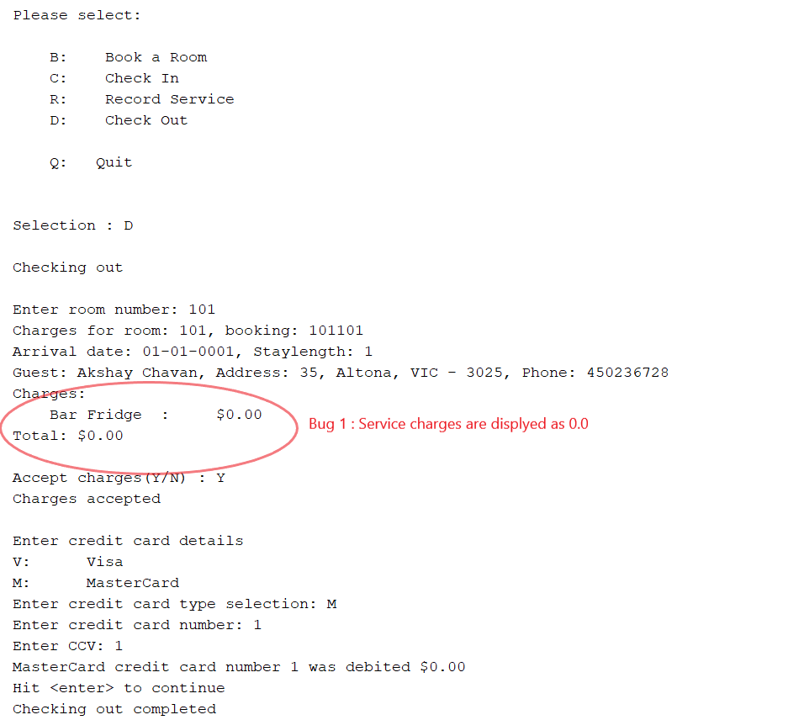

The second bug is that even after the guest has checked out the services can still be added. As shown in the previous screenshot, the guest has successfully checked out. But later I selected the record services case and wrote the room number. The room was charged again, and the guest could again check out. This is the second bug. The screenshot is below

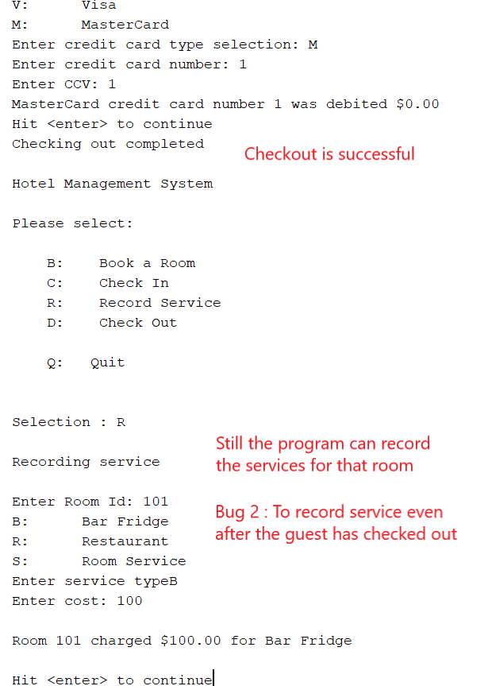

Secondly the guest can check out even after guest has already checked out and with incorrect service charges.

